# Sample Questions

# Short Answer Type Questions:

1. Differentiate an activity diagram from a state diagram.
2. What is CRC?
3. Compare and contrast a sequence and a collaboration diagram.
4. What is the relationship between abstraction, information hiding, and encapsulation?
5. Differentiate between activity diagrams, flow charts, and state transition diagrams.
6. Name the UML diagrams used for the following: (i) modelling requirements (ii) modelling workflows (iii) modelling behaviour of an object (iv) interaction between groups of objects.
7. Why is object orientation needed?
8. What is use case modelling?
9. Explain 5 views of system in OOAD.
10. Differentiate static and dynamic models
11. Why unified modelling language is needed?
12. What is a part of relationship?
13. Differentiate between an action and use case.
14. Compare sequence versus collaboration diagram.
15. Draw a state diagram to depict the states of the CPU.
16. Explain about different types of class visibilities.
17. What is the purpose of class diagram? Explain.
18. Differentiate between UML and OOAD.
19. Describe about 7 phases of SDLC.
20. Explain why object oriented approach is preferable when compared to other approaches?
21. Define association and aggregation.
22. Define Events, States, Signal, and Transition.
23. Define Unified Process (UP). List the 4 phases of UP.
24. Generalize your views about inception in use case.
25. Compare Aggregation and Composition.
26. Describe the preconditions and post conditions in activity diagram for ATM machine money withdrawal.
27. Generalize the use of Sequence Diagram.
28. Differentiate Class diagram and Interaction diagram.
29. Analyze the concepts of Noun Phrase Identification from use cases.
30. When to use class diagram?
31. Describe the UML notation for class diagram with example.
32. Describe the concepts of link, association and Inheritance.
33. Describe the difference between elaboration and inception with an example

# Medium / Long Answer Type Questions

1. Compare and contrast the Booch and Rumbaugh methodologies.

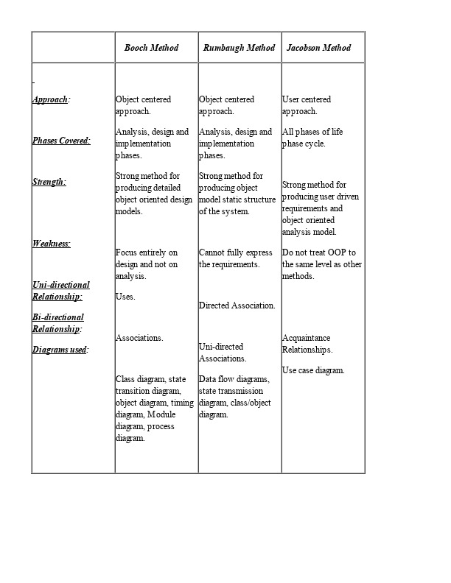

1. Explain Use-case driven approach in object oriented system development with the payroll system as a case study.

The use case diagram are usually referred to as behavior diagram used to describe the actions of all user in a system. All user describe in use case are actors and the functionality as action of system. The Use case diagram is a collection of diagram and text together that make action on goal of a process.In this Employee Payroll Management system website project there are two actors can do all the activities to run the system. Admin, and Employee.

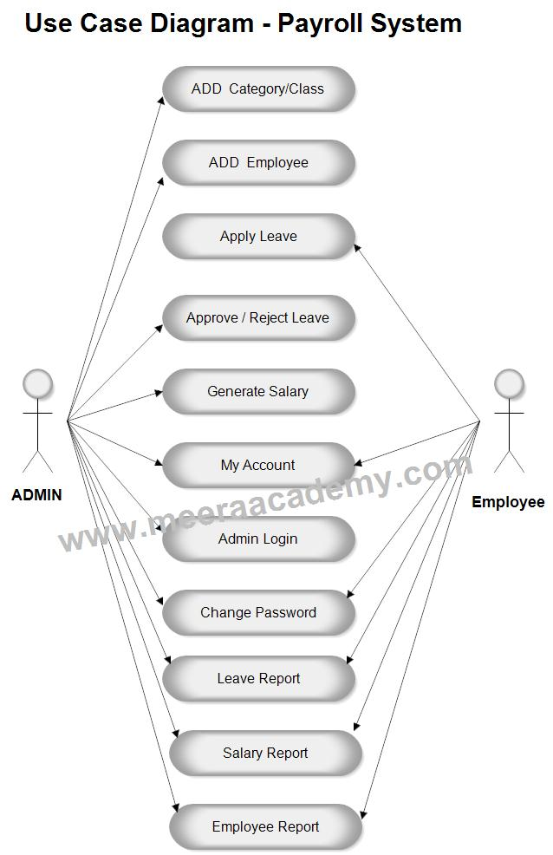

1. Develop an activity diagram to show the business process of the library.

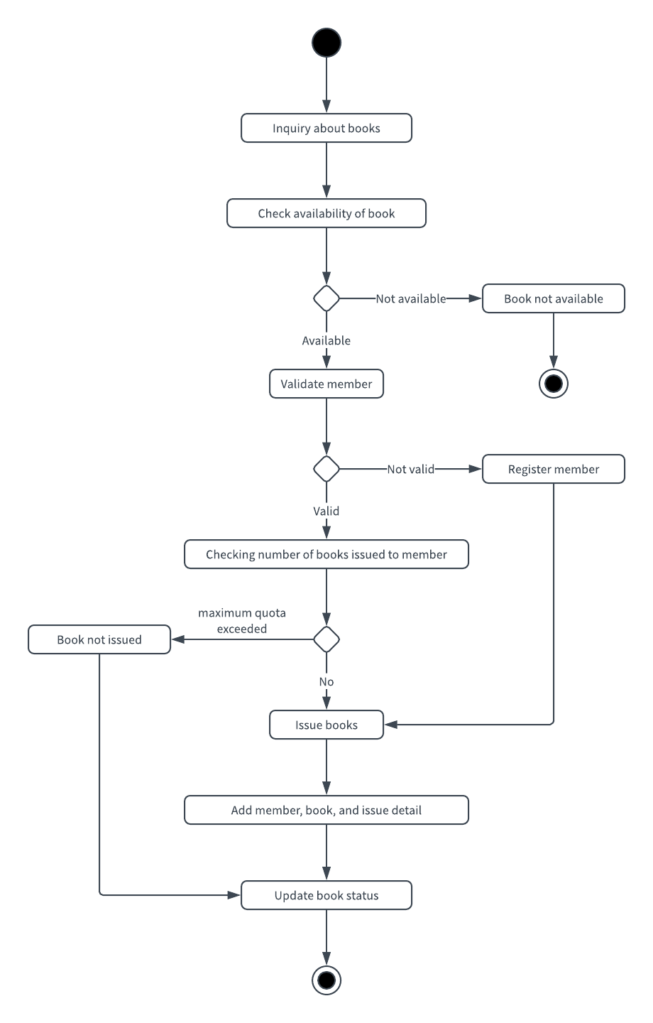

1. Show the activities involved in an ATM transaction.

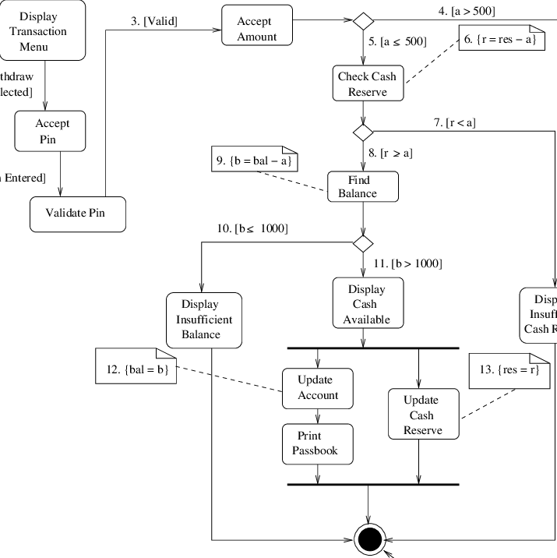

1. Develop sequence / collaboration diagrams for the following use case of the banking system: Identify all the classes, responsibilities and collaborators processes for the objects. (i) Deposit in saving account (ii) Withdrawal from saving account (both acceptance and denial) (iii) Balance checking
2. What is object-oriented SDLC? Compare it with traditional approaches.

 Any software development approach goes through the following stages –

1.analysis2.design3.implementation

* Analysis, In this stage, the problem is formulated, user requirements are identified, and then a model is built based upon real–world objects. The analysis produces models on how the desired system should function and how it must be developed. The models do not include any implementation details so that it can be understood and examined by any non–technical application expert.
* Design,

**System Design**

In this stage, the complete architecture of the desired system is designed. The system is conceived as a set of interacting subsystems that in turn is composed of a hierarchy of interacting objects, grouped into classes. System design is done according to both the system analysis model and the proposed system architecture. Here, the emphasis is on the objects comprising the system rather than the processes in the system.

**Object Design**

In this phase, a design model is developed based on both the models developed in the system analysis phase and the architecture designed in the system design phase. All the classes required are identified. The designer decides whether −

* new classes are to be created from scratch,
* any existing classes can be used in their original form, or
* new classes should be inherited from the existing classes.

The associations between the identified classes are established and the hierarchies of classes are identified. Besides, the developer designs the internal details of the classes and their associations, i.e., the data structure for each attribute and the algorithms for the operations.

* Implementation. In this stage, the design model developed in the object design is translated into code in an appropriate programming language or software tool. The databases are created and the specific hardware requirements are ascertained. Once the code is in shape, it is tested using specialized techniques to identify and remove the errors in the code.

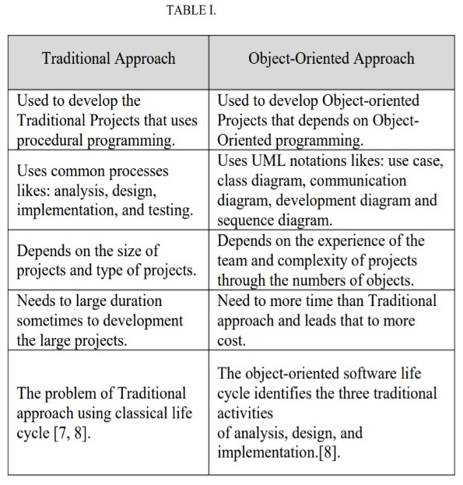

1. Describe in detail the major and minor elements of object model. Give suitable examples.

<https://www.tutorialspoint.com/object_oriented_analysis_design/ooad_object_oriented_principles.htm>

1. How is the use case model useful in every phase of software development? Discuss.
2. Use case diagrams are used to gather the requirements of a system including internal and external influences.
3. These requirements are mostly design requirements. So when a system is analyzed to gather its functionalities use cases are
4. prepared and actors are identified. The research article focuses on identification of significance of use case diagram in
5. software development. As per findings of this article we can easily conclude the significance of use case diagram is increasing
6. as the size of the project increases. As the size of project may be directly related with the extent of complexity of project. Large
7. & complex projects always need the help of use case diagram so that developers can easily understand the requirements of
8. Use case diagrams are used to gather the requirements of a system including internal and external influences.
9. These requirements are mostly design requirements. So when a system is analyzed to gather its functionalities use cases are
10. prepared and actors are identified. The research article focuses on identification of significance of use case diagram in
11. software development. As per findings of this article we can easily conclude the significance of use case diagram is increasing
12. as the size of the project increases. As the size of project may be directly related with the extent of complexity of project. Large
13. & complex projects always need the help of use case diagram so that developers can easily understand the requirements of
14. Use case diagrams are used to gather the requirements of a system including internal and external influences.
15. These requirements are mostly design requirements. So when a system is analyzed to gather its functionalities use cases are
16. prepared and actors are identified. The research article focuses on identification of significance of use case diagram in
17. software development. As per findings of this article we can easily conclude the significance of use case diagram is increasing
18. as the size of the project increases. As the size of project may be directly related with the extent of complexity of project. Large
19. & complex projects always need the help of use case diagram so that developers can easily understand the requirements of

Use case diagrams are used to gather the requirements of a system including internal and external influences. These requirements are mostly design requirements. So when a system is analyzed to gather its functionalities use cases are prepared and actors are identified. The research article focuses on identification of significance of use case diagram in software development. As per findings of this article we can easily conclude the significance of use case diagram is increasing as the size of the project increases. As the size of project may be directly related with the extent of complexity of project. Large & complex projects always need the help of use case diagram so that developers can easily understand the requirements of the system.

Purpose:

The purpose of use case diagram is to capture the dynamic aspect of a system. But this definition is too generic to describe the purpose.Because other four diagrams (activity, sequence, collaboration and State chart) are also having the same purpose. So we will look into some specific purpose which will distinguish it from other four diagrams.Use case diagrams are used to gather the requirements of a system including internal and external influences. These requirements are mostly design requirements. So when a system is analyzed to gather its functionalities use cases are prepared and actors are identified.Now when the initial task is complete use case diagrams are modelled to present the outside view.

So in brief, the purposes of use case diagrams can be as follows:

•Used to gather requirements of a system.

•Used to get an outside view of a system

.•Identify external and internal factors influencing the system.

•Show the interacting among the requirements are actors

1. Draw the use case model for the following system and explain. Also use noun phrase approach to identify the classes and their attributes. Explain the process.

A computerized banking network includes both human cashiers and automatic teller machines (ATM) to be shared by a consortium of banks. Each bank provides its own computer to maintain its own accounts and process transactions against them. Cashier stations are owned by individual banks and communicate directly with the bank computers. Human cashiers enter account and transaction data ATM accepts a cash card, interacts with the user, communicates with the central computer to carry out the transaction, dispenses the cash and prints receipts. The system requires appropriate record keeping and security provisions. The system must handle concurrent accesses to the same account correctly.

1. Describe the components of the unified approach with a neat diagram.
2. What are the models proposed by OMT? Give their purpose.

<https://www.geeksforgeeks.org/software-engineering-object-modeling-technique-omt/>

1. Consider “buy tickets” use case in a railway reservation system. Draw a sequence diagram. Explain briefly.

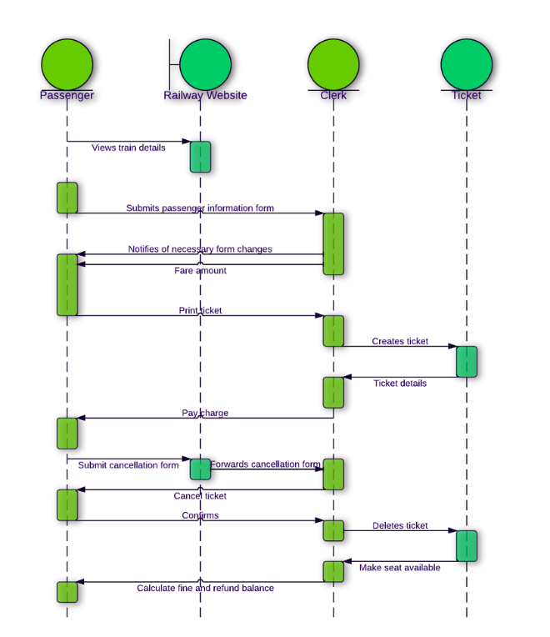

1. Explain in detail the various properties of object-oriented systems. Illustrate with suitable examples.

<https://www.tutorialspoint.com/object_oriented_analysis_design/ooad_object_oriented_system.htm>

1. The Small Library Database System will be used by the Biology Department of a local college to track the borrowing of books and other froms of media, such as video tapes, and software. A secretary will operate the system and will responsible for checking out books to students and faculty members. Identify objects and relationships among them using Noun phrase approach. Describe the approach used.
2. What is the use of use-case diagram? Differentiate between the roles of actors and users.

<https://www.javatpoint.com/uml-use-case-diagram>

<https://enfocussolutions.com/actors-and-users/#:~:text=Software%20products%20are%20created%20for,devices%2C%20or%20other%20software%20systems.&text=An%20actor%20is%20an%20entity,execution%20of%20a%20use%20case.>

1. Draw and explain the use-case diagram for a library management system.

<https://www.geeksforgeeks.org/use-case-diagram-for-library-management-system/>

1. Briefly explain the Object Oriented system Development Life Cycle.

<https://www.tutorialspoint.com/uml/uml_deployment_diagram.htm>

1. Discuss briefly the Booth Methodology for object modelling.

<http://www.dba-oracle.com/t_object_oriented_analysis_models.htm>

1. Briefly explain about Class diagram with an example.

<https://www.tutorialspoint.com/uml/uml_class_diagram.htm>

1. Explain different types of relationships among classes and objects.

<https://www.c-sharpcorner.com/article/types-of-relationships-in-object-oriented-programming-oops/#:~:text=Object%20oriented%20programming%20generally%20support,%22part%2Dof%22%20relationship.>

1. Describe the activities of object-oriented system development life cycle.
2. Explain Rumbaugh’s methodology of object oriented development process.

<http://www.dba-oracle.com/t_object_oriented_analysis_models.htm>

1. Identify the use-cases, classes, and relationships for the Bank ATM system. Also give the use case diagram and class diagram for the Bank ATM system.

<https://www.geeksforgeeks.org/use-case-diagram-for-bank-atm-system/>

every diagram of bank atm

<http://groups.umd.umich.edu/cis/course.des/cis375/active/class6/UML-ATM.pdf>

Explain the noun phrase approach to identify the classes for a library information system.

1. What are the structural and behavioural UML diagrams.

<https://www.tutorialspoint.com/uml/uml_modeling_types.htm>

1. Describe in detail the different views in Booch methodology. Compare with the models in OMT methodology.

<http://www.dba-oracle.com/t_object_oriented_analysis_models.htm>

2nd part same as q1.

1. Explain the different relationship between classes. Identify and show the relationship between classes in the following statement:

“An airline company has employees. A team builds an airplane which has a number of components. An airline lands and takes off from an air strip in an airport. The airplane carries passengers from a source to destination. An airplane is managed by a captain and co-pilot along with his cabin crew consisting of airhostess and attendants”.

1. What are the approached used for identification of classes and attributes? Explain.
2. Draw a UML class diagram for the people within the university. Provide a person class

– A person may be a citizen or foreigner male or female. Each person may play the role of a student or employee. Employee can be either professor or registrar. Student may be a under-graduate, master-student or PhD student.

1. Define generalization and aggregation. Define in detail how they could be applied to actual situations.
2. Explain about forking and joining concepts in the activity diagram with an example.
3. Define the following terms:
   * Events and Signals
   * Process and Thread
   * Time and Space
4. Prepare an activity diagram that elaborates the details of logging into an email system. Explain the steps with a neat diagram.
5. Describe about the relationships types in UML.
6. Define component. What are the differences between components and classes? How are component and interface related?
7. Discuss the uses, concepts and notations are used in Sequence Diagram.
8. Describe briefly about association classes and association role.
9. A University conducts examinations and the results are announced. Prepare a report for the following:

* Print the marks in the register number order semester wise for each department
* Print the Arrear list semester wise.
* Prepare a Rank list for each department.
* Prepare the final aggregate mark list for final year students.

Identify the problem statement and Design and Explain the classes for each sequence. Design the Use case, Class, and Sequence diagrams for designing this system.

1. Analyze and design for Library Information System which comprises the following notations and explain them. (i)Aggregation (ii) Composition (iii) Association.
2. Illustrate the concepts and uses of Communication Diagram.
3. Compare Activity and state chart diagram? Mention the Elements of an Activity Diagram.
4. List out the Types of Interactions diagram.
5. Differentiate the strengths and weaknesses of Sequence and Communication Diagram.
6. Interpret the meaning of event, state and Transition
7. Define State Chart Diagram? When to use State Diagram?
8. Explain how Synchronous and asynchronous messages are depicted in communication diagram.
9. Differentiate Component and deployment diagram
10. Analyze the use of UML Package Diagram
11. When to use Deployment diagram? Analyze it
12. Describe the basic elements of a Deployment Diagram.
13. What is package diagram? Classify the three layers of package diagram
14. When to use Component Diagram? Analyze it.
15. List the two types of deployment diagram node.
16. When to use activity diagrams. Describe the situations with example.
17. Consider the hospital management system application with the following requirements.

(i).System should handle the in-patient, out - patient information through receptionist. (ii). Doctors are allowed to view the patient history and give their prescription.

(iii). There should be a information system to provide the required information. Explain and give state chart, component and deployment diagrams.

1. What is Collaboration diagram? How does it differ from sequence diagram? Design the Collaboration diagram to model the details of a seminar. The display is to obtain the details of seminar and the courses enrolled in the seminar. Then it obtains the details of the seminar. The display is to obtain the details of seminar and the courses enrolled in the seminar. Then it obtains the details of the students enrolled in the seminar. It finds the number of seats left to enroll for the seminar.
2. . For Airline Ticket reservation system explain and draw the following UML diagrams (i).sequence and Collaboration diagram(booking a ticket)

(ii). Activity diagram. (iii). State chart diagram.